Install Vagrant and Spin up Ubuntu

To install Vagrant:

1. Download the vagrant installer from its official downloads page.

* ***https://developer.hashicorp.com/vagrant/downloads***

1. Vagrant requires a virtualization software to run virtual machines, hence we install Virtual Box using the installer from the VirtualBox downloads page.

* ***https://www.virtualbox.org/wiki/Downloads***

1. Verify if the installation was successful by running the following command in Command prompt or PowerShell.

* ***vagrant –version***

To spin up Ubuntu on Vagrant:

1. Vagrant uses pre-made boxes to spin up virtual machines. You can find Ubuntu boxes on the Vagrant website at

* <https://app.vagrantup.com/boxes/search>.
* Note down the name of the ubuntu box

1. Open a new terminal window (Command Prompt) and navigate to the directory where you want to create the vagrantfile. Once in the directory run the following command to create a new vagrantfile

* ***vagrant init <box-name>***

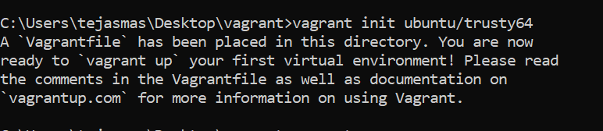

1. Open the Vagrantfile and make changes to the configuration to match your needs. Once done save and close the file.
2. To the start the virtual machine, run the following command

* ***vagrant up***
* **Note:** If an error occurs, add the given line to the vagrantfile and save it and re-run “***vagrant up***” command.
  + ***config.vm.box_download_insecure=true***

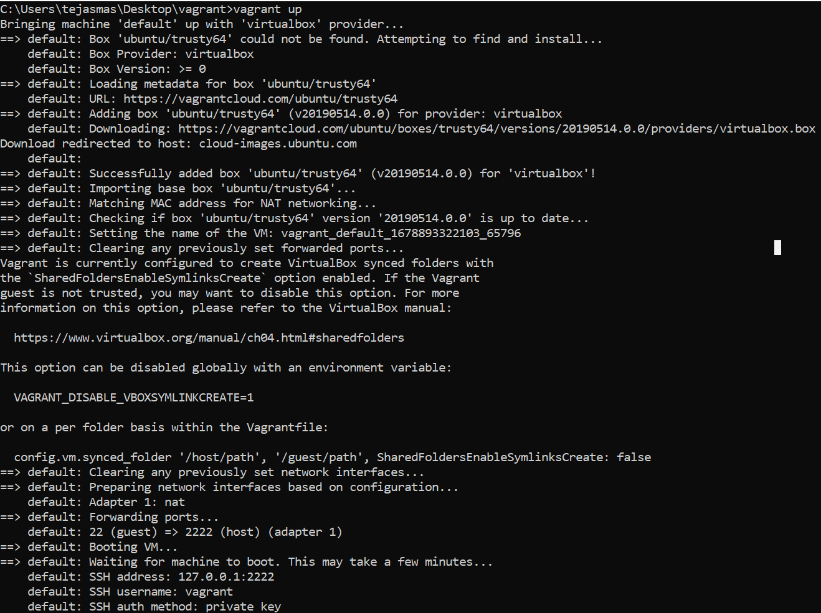

1. Vagrant will install the ubuntu box and a new virtual machine will be set up with the given configurations.
2. Once the virtual machine has started, run the following command to connect it via ssh

* ***vagrant ssh***

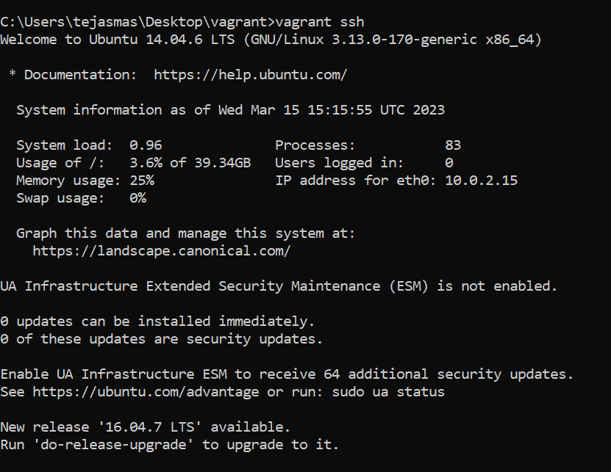

These steps will spin up an Ubuntu machine on Vagrant.